Interactive Map: Mascot Design Document

Introduction:

Upon inspecting the current build of the interactive map artefact, a suggestion was made by Mel for the inclusion of a ‘mascot’ or ‘non-playerable’ character. The interactive map design team saw it best to inquire into any design preferences when pertaining to likeness the museum held for the mascot. The preferences received can be found listed below.

* Basil Brown
* Nina Layard
* Mammoths

Going forward an anthropomorphised mammoth akin to the likeness of Basil Brown was chosen as the preferred mascot design.

Background:

Born Basil John Wait Brown (22 January 1888 – 12 March 1977), Brown was a self-taught archaeologist and astronomer native to the Suffolk area. Additionally, mammoths were suggested as they are the current mascot of the museum.

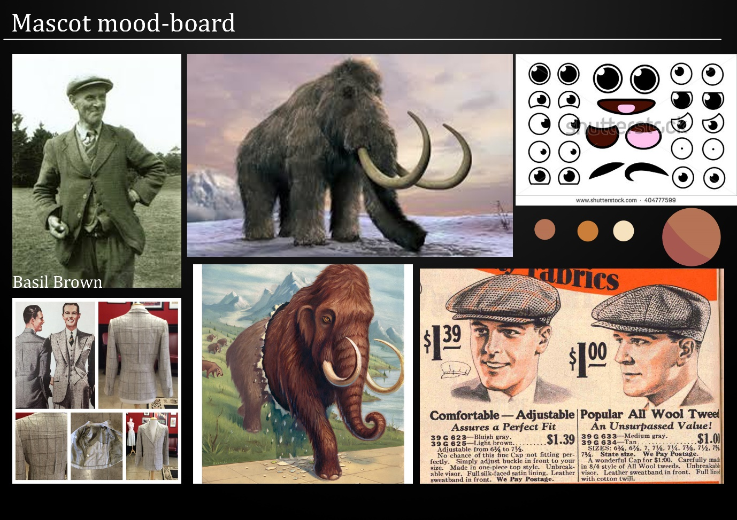Mood board and drafts:

Mood board

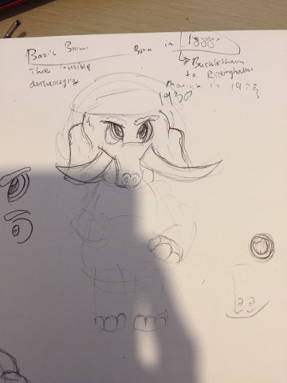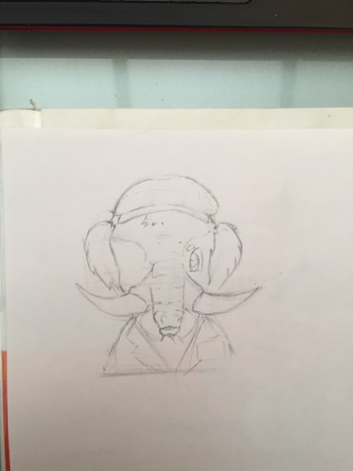

Concept Two

Concept One



Final design: Basil the Mammoth

Placement Mock-up

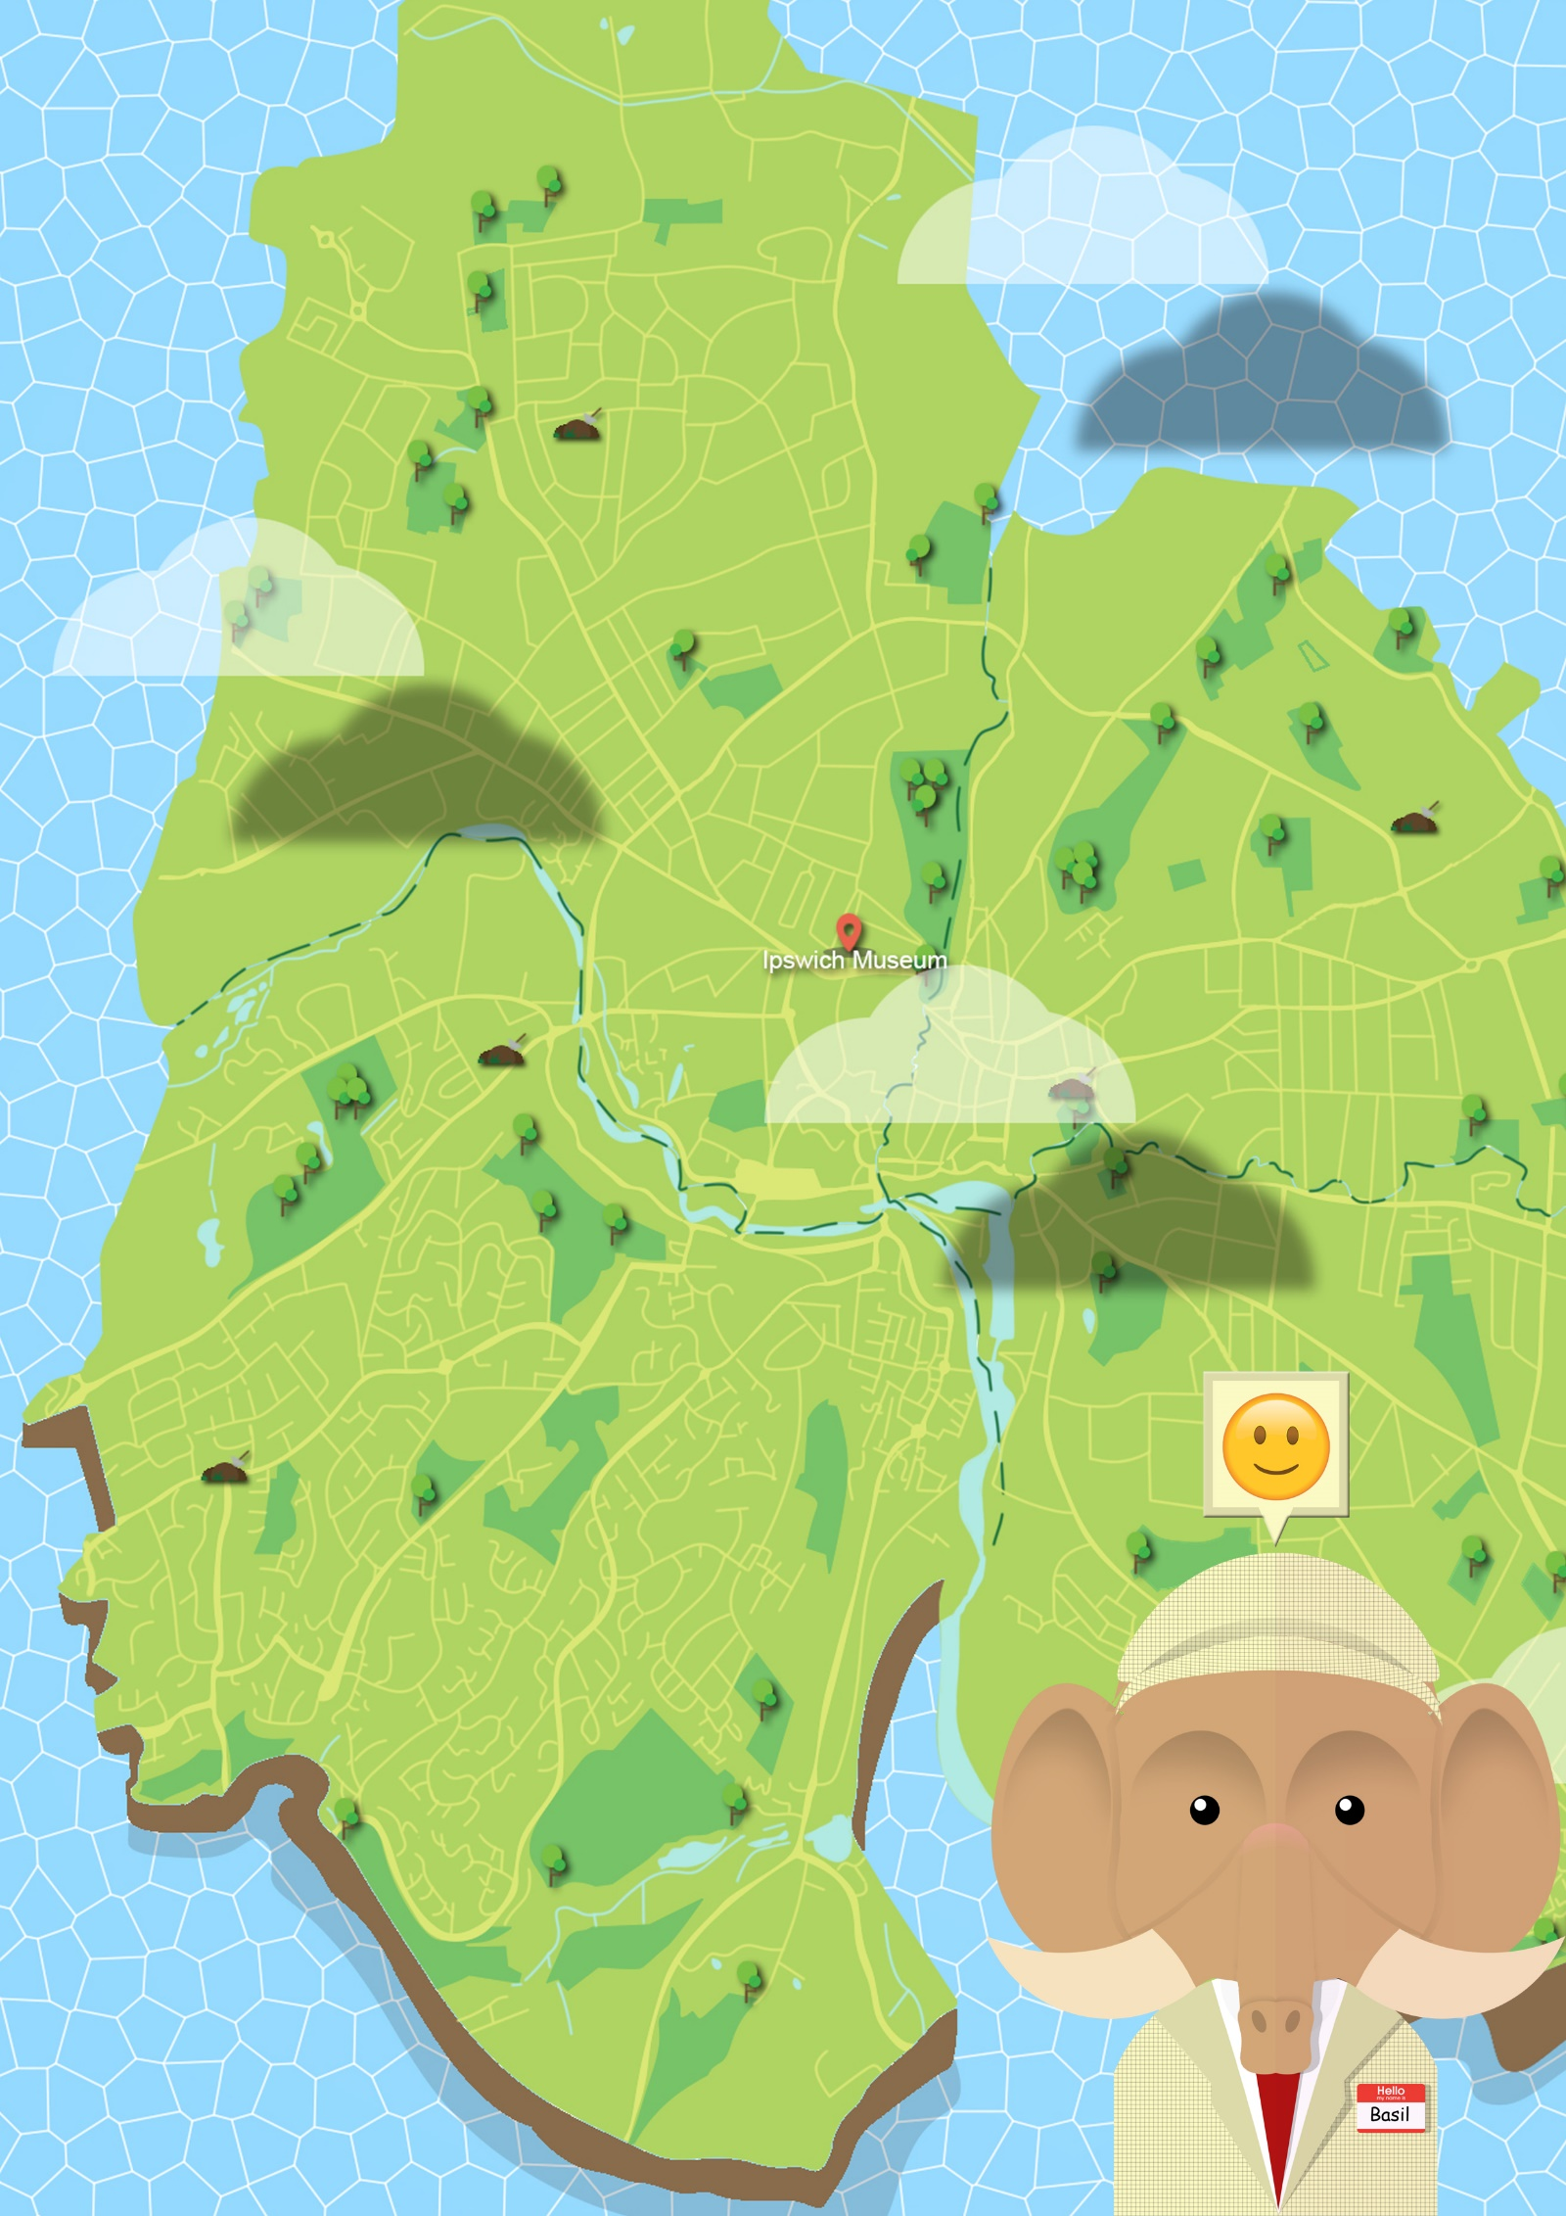

Emoticon bubbles

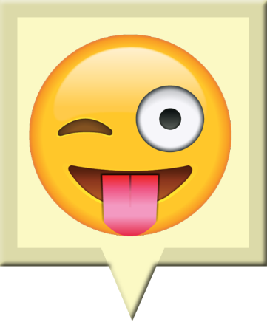

Neutral

Incorrect

Correct

These emoticon bubbles will be located slightly above the mascots head (see mock-up for reference) and will coincide with the player’s current interaction with the map. The Neutral bubble will be the default, however the bubble may change depending on whether players answer question correctly or incorrectly before reverting back to the neutral after a brief cool down timer.

Emoji source:

Emoji island. (2017). *Free Download Emoji Icons in PNG [IOS 9].*Available: https://emojiisland.com/pages/free-download-emoji-icons-png. Last accessed 02/01/2018.